**Smart Property Detection CRM Project Documentation**

**Name:** K. Durga Lakshmi  
**Project Title:** Smart Property Detection CRM Project

**Project Overview**

The Smart Property Detection CRM project manages properties, visits, and leads efficiently in Salesforce. It automates property and visit tracking, lead management, and reporting to save time, reduce errors, and provide actionable insights for real estate teams.

**Objectives**

* Streamline property, visit, and lead management in one platform.
* Automate notifications, approvals, and validations for accuracy.
* Enable reporting and dashboards for better decision-making.
* Provide a scalable solution for future enhancements.

**Phase 1: Problem Understanding & Industry Analysis**

* Requirement Gathering
* Stakeholder Analysis
* Business Process Mapping
* Industry-specific Use Case Analysis
* AppExchange Exploration

**Phase 2: Org Setup & Configuration**

* Salesforce Edition & Company Profile Setup
* Business Hours & Holidays, Fiscal Year Settings
* User Setup & Licenses, Login Access Policies
* Dev Org & Sandbox Usage, Deployment Basics
* 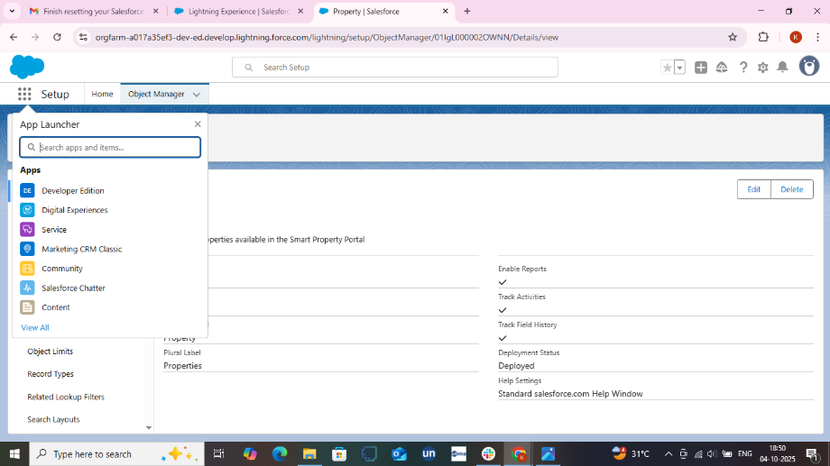

**Fig : Salesforce App Launcher**

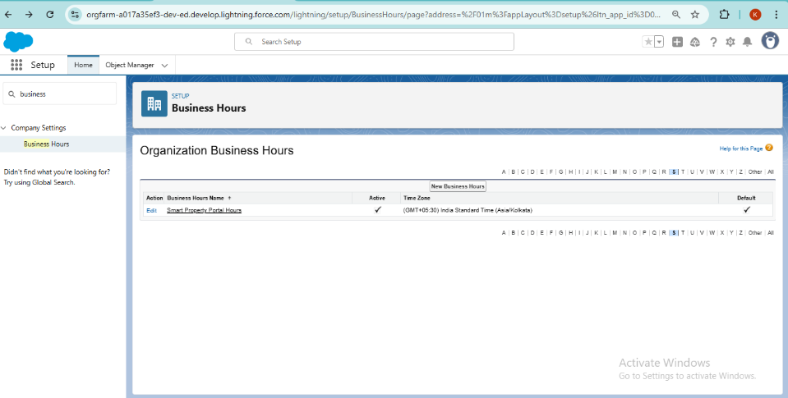 **Fig: Organization Hours**

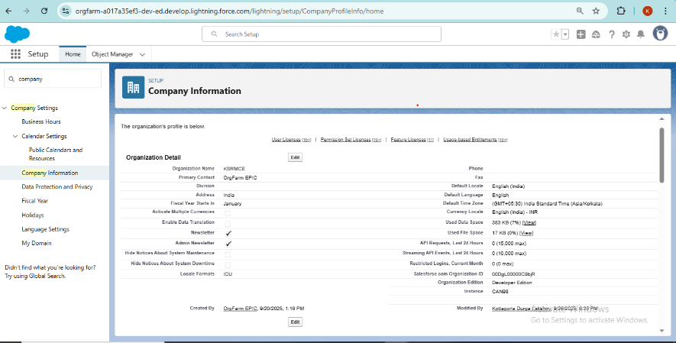

**Fig: Company Information**

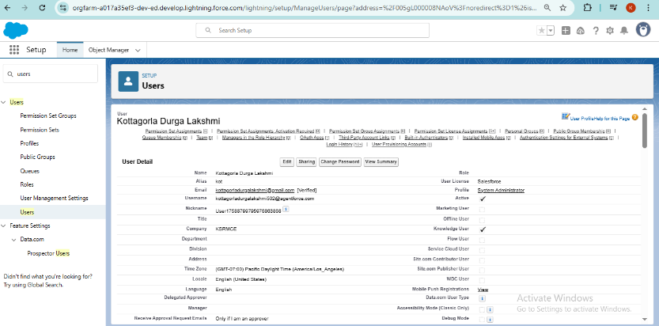

**Fig: Users Setup**

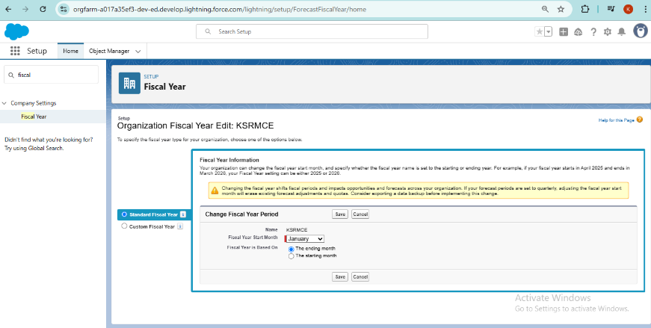

**Fig: Fiscal Year**

**Phase 3: Data Modelling & Relationships**

* Created standard & custom objects: Property, Visits, Leads
* Fields, Record Types, Page Layouts, Compact Layouts
* Lookup & Master-Detail relationships among objects

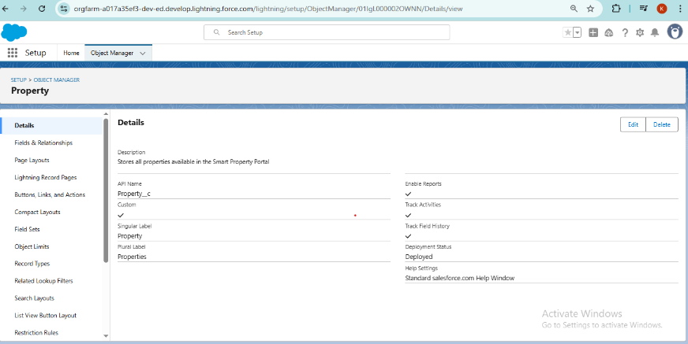

**Fig : Property**

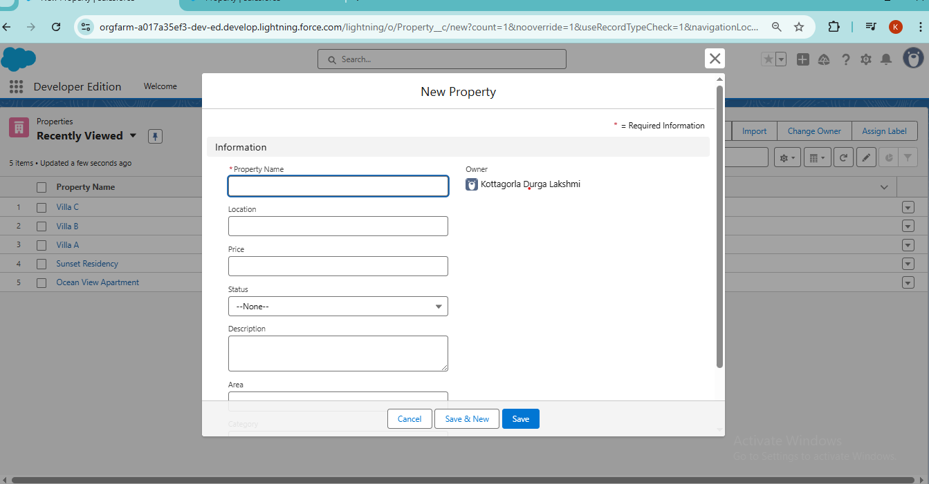

**Fig 2.2: Create New Property**

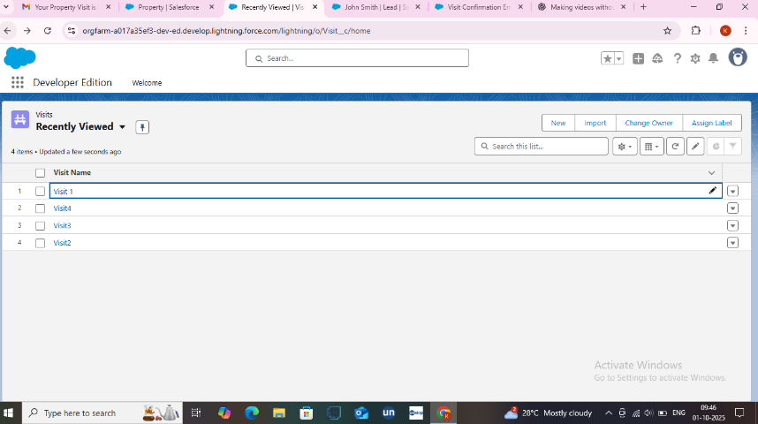

**Fig: Visits**

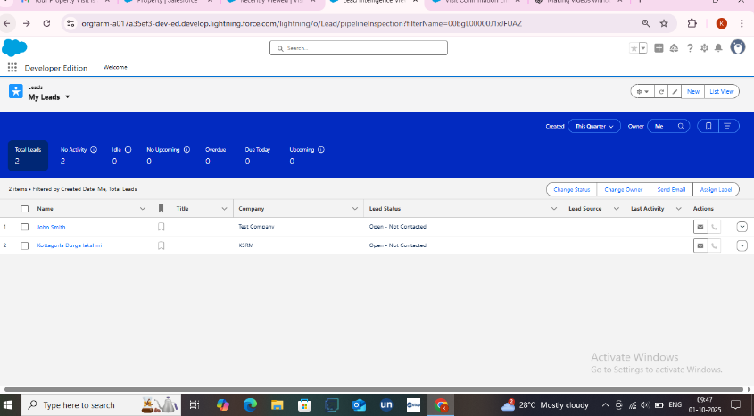

**Fig: Leads**

**Phase 4: Process Automation (Admin)**

* Validation Rules, Workflow Rules, Process Builder
* Approval Processes & Flows (Screen, Auto-launched)
* Email Alerts, Field Updates, Tasks, Custom Notifications

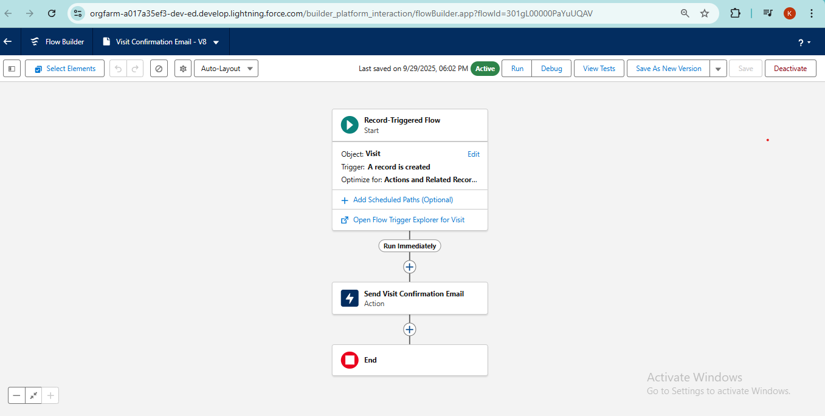

**Fig: Record Triggered Flow**

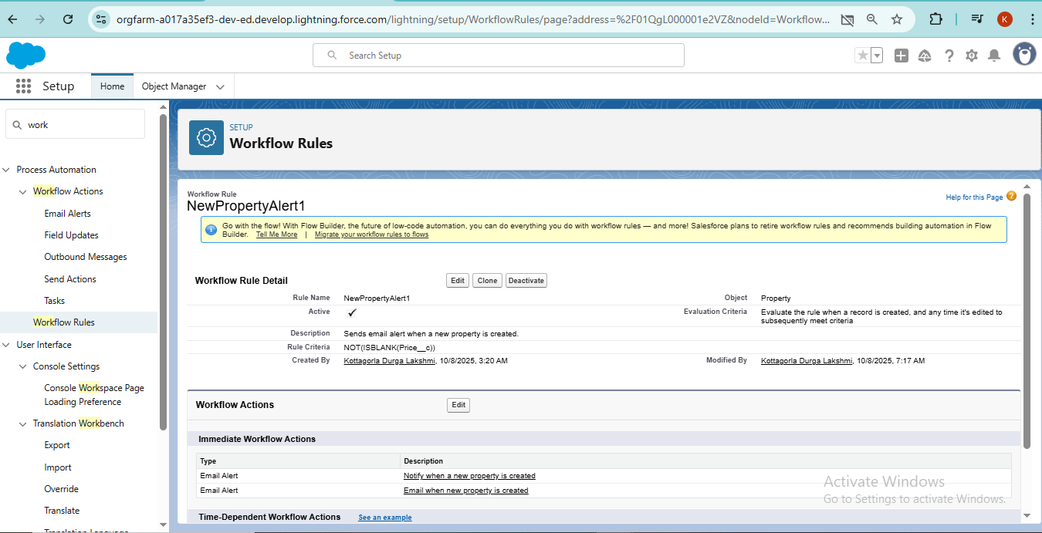

**Fig: Work Flow Rule**

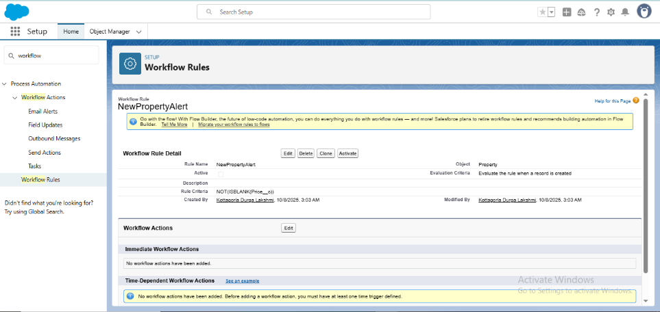

**Fig: Work Flow Property**

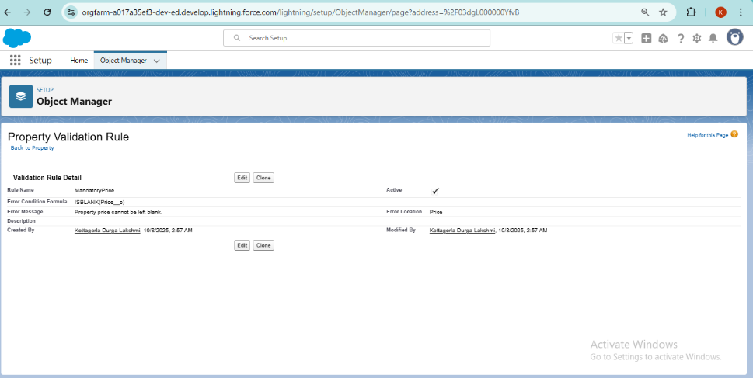

**Fig: Validation Rule**

**Phase 5: Apex Programming (Developer):**

* Apex Triggers (before/after insert/update/delete)
* Trigger Design Pattern, SOQL & SOSL queries
* Collections: List, Set, Map; Control Statements
* Scheduled, Batch, Queueable Apex; Exception Handling;

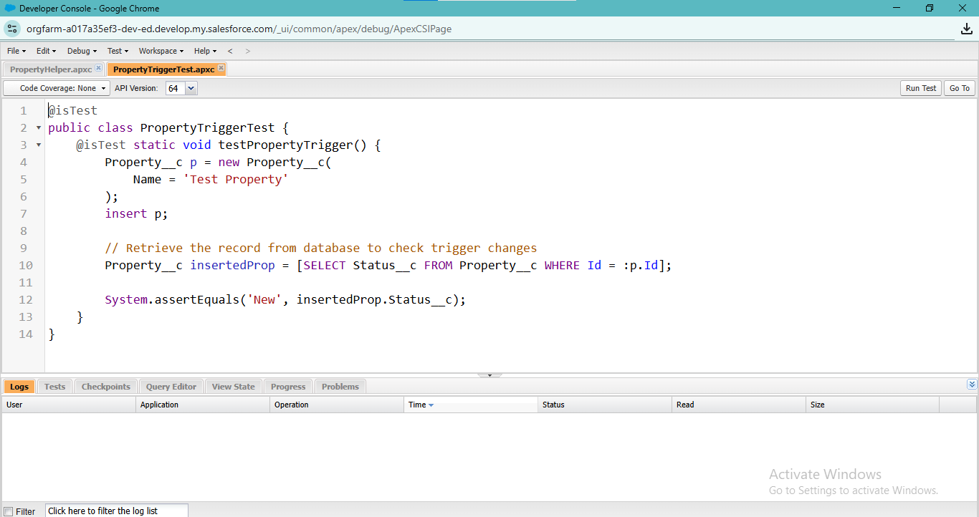

**Fig: Apex Property Triggering**

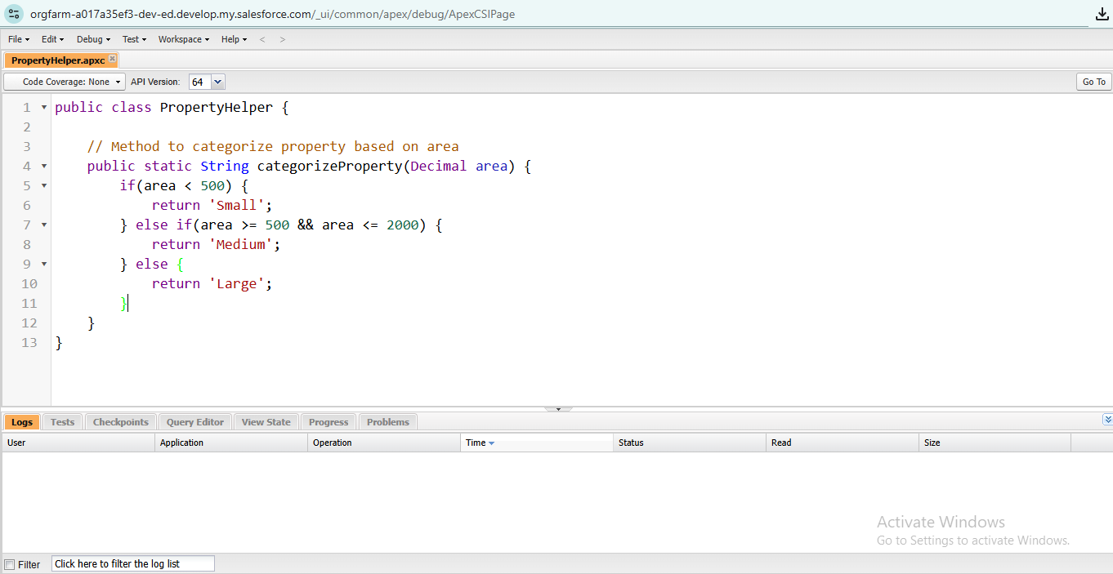

**Fig: Apex Trigger**

**Phase 6: User Interface Development**

* Lightning App Builder, Record Pages, Tabs, Home Page Layouts
* Utility Bar, LWC components, Apex integration
* Events in LWC, Wire Adapters, Imperative Apex Calls, Navigation

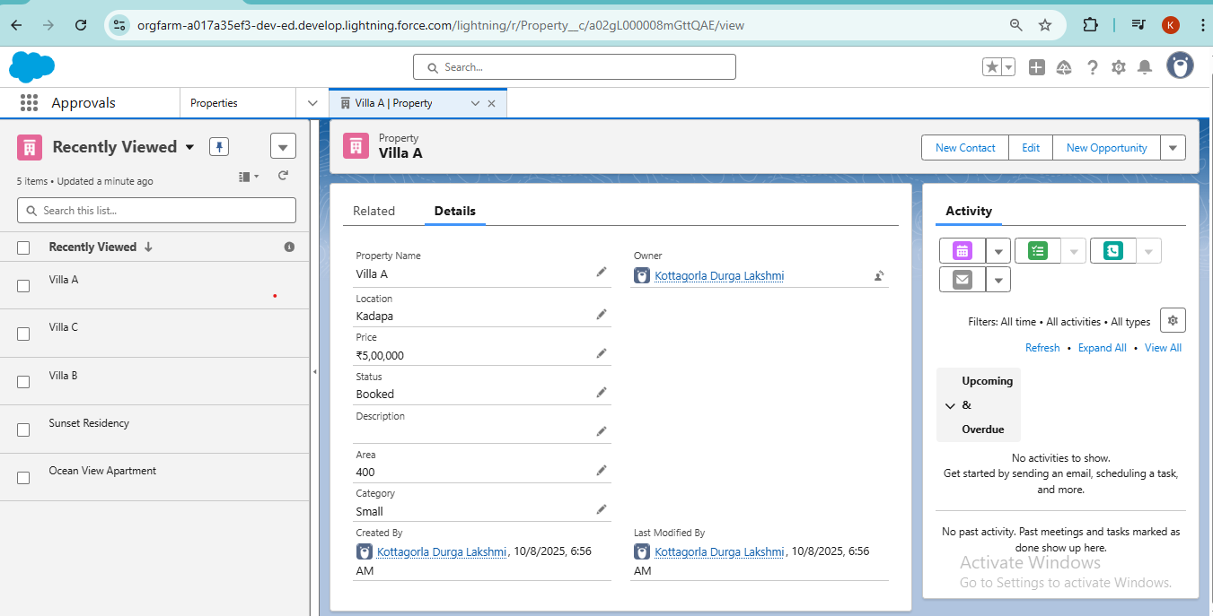

**Fig: Property Record**



**Fig: Create New Property**

**Phase 7: Integration & External Access**

* Named Credentials, External Services, REST/SOAP Web Services, Callouts
* Platform Events, Change Data Capture, Salesforce Connect
* API Limits, OAuth & Authentication, Remote Site Setting
* 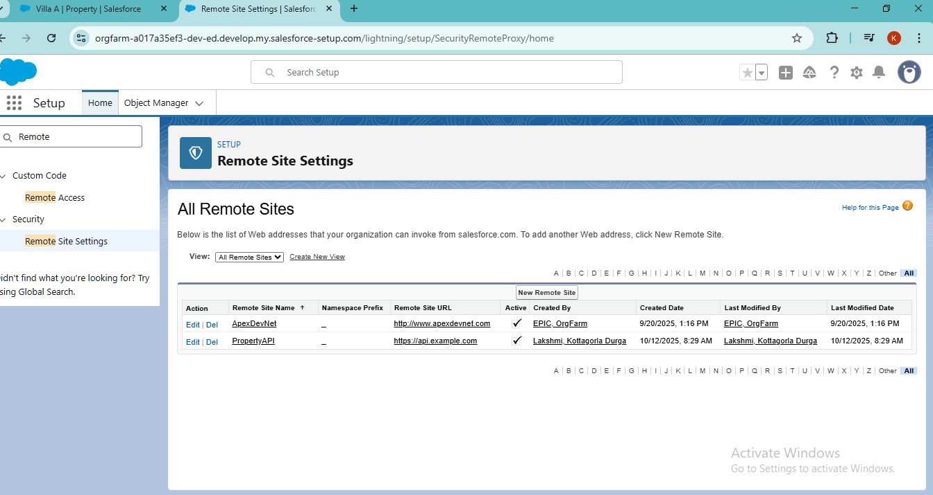

**Fig: Remote Site Settings**

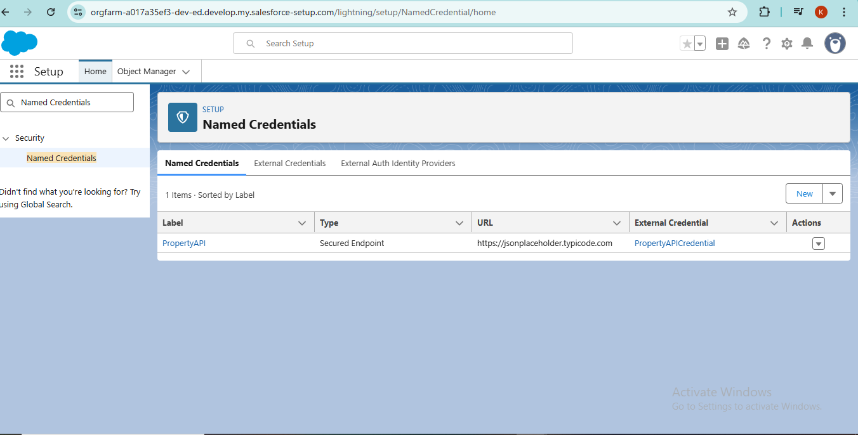

**Fig: Named Credentials**

**Phase 8: Data Management & Deployment**

* Data Import Wizard, Data Loader, Duplicate Rules
* Data Export & Backup, Change Sets, Packages
* ANT Migration Tool, VS Code & SFDX

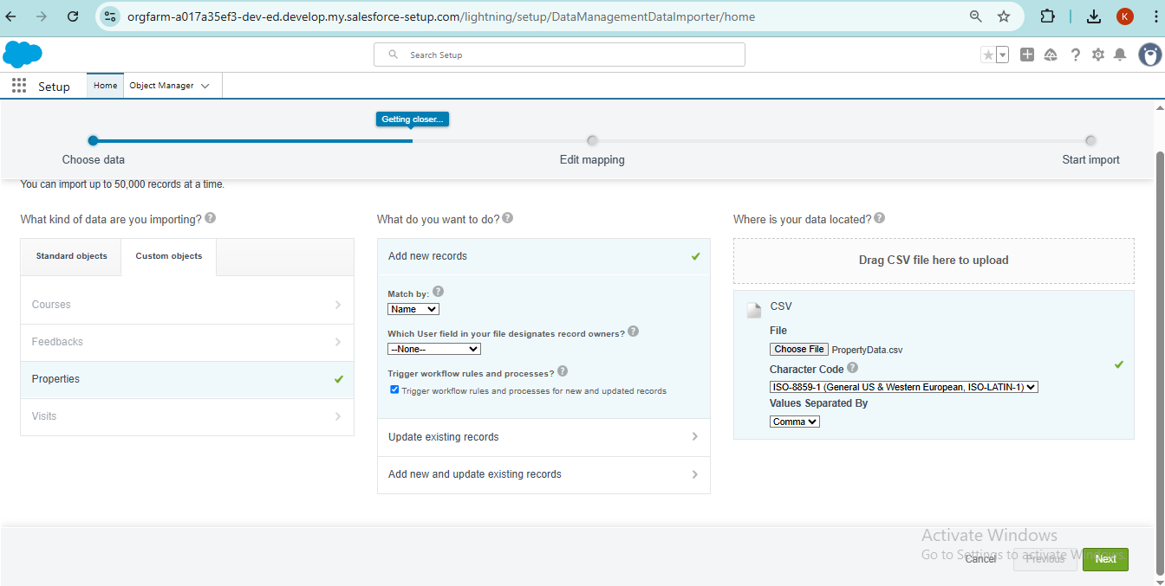

**Fig: Data Import**

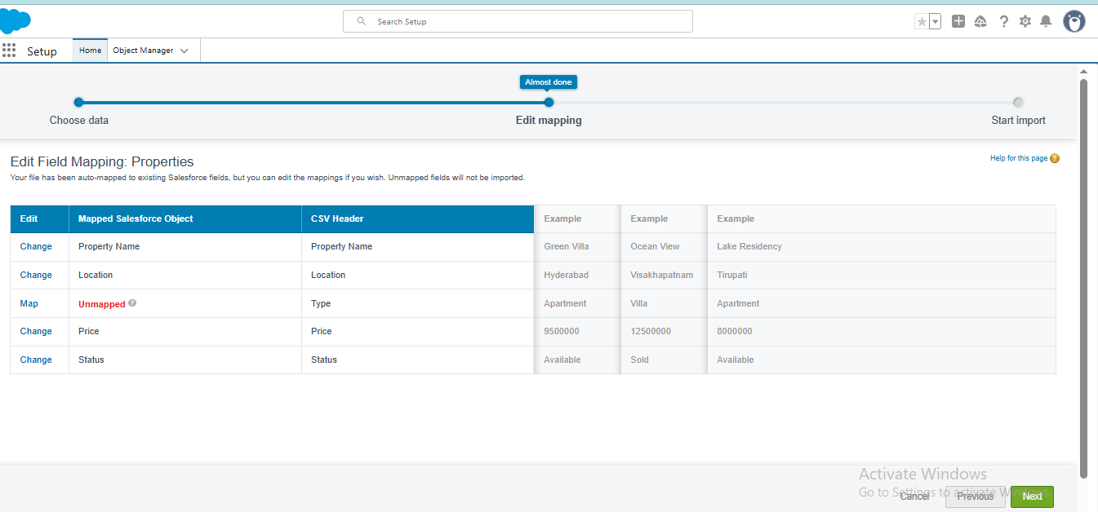

**Fig: Field Mapping Properties**

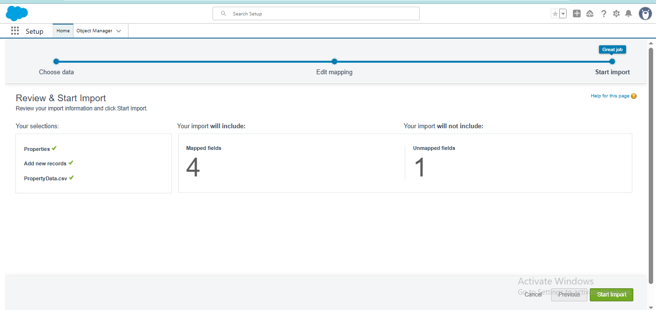

**Fig: Imported Data**

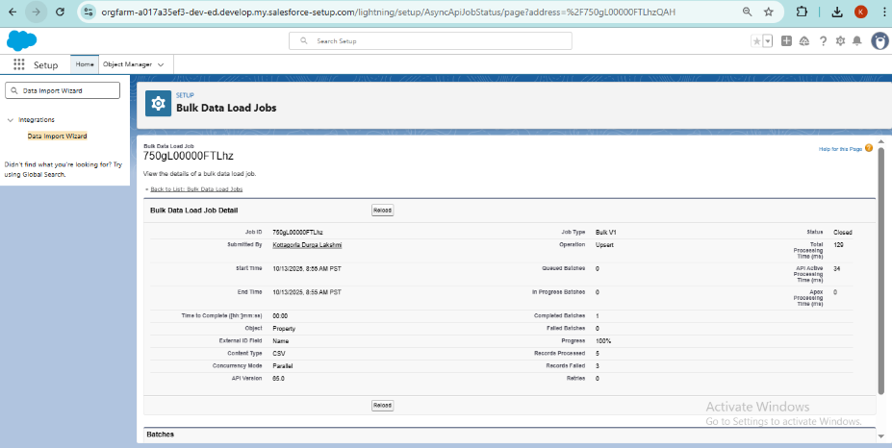

**Fig: Bulk Data Load Jobs**

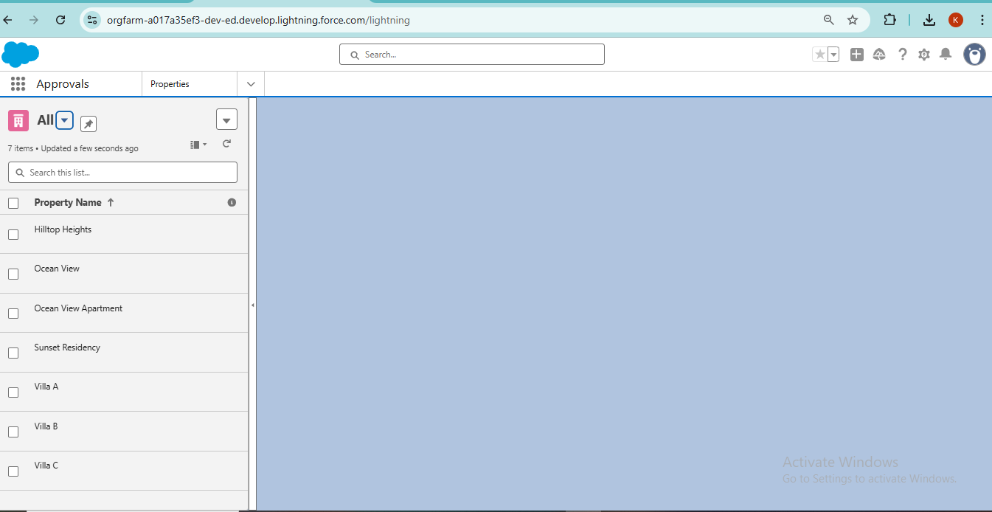

**Fig: Properties Imported**

**Phase 9: Reporting, Dashboards & Security Review**

* Reports (Tabular, Summary, Matrix, Joined), Report Types
* Dashboards & Dynamic Dashboards
* Profiles, Roles, Users, Permission Sets, OWD
* Sharing Rules, Field Level Security, Session Settings, Audit Trail

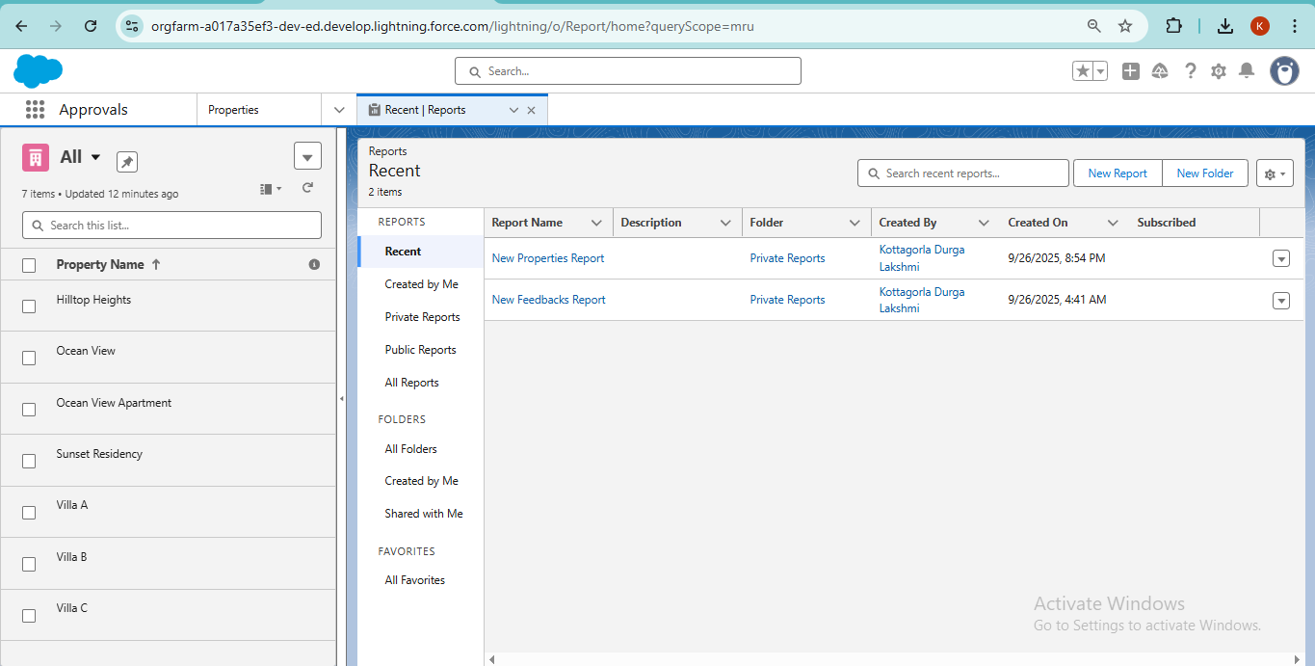

**Fig: Reports**

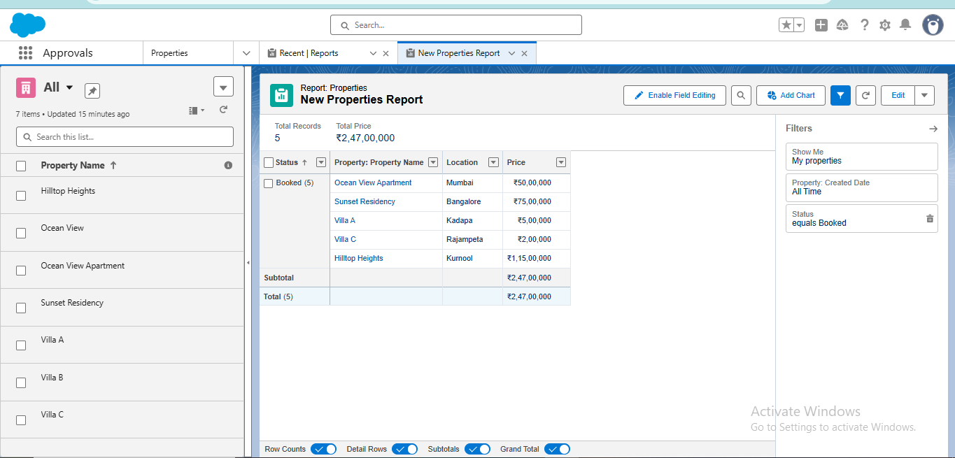

**Fig: Reports Filters**

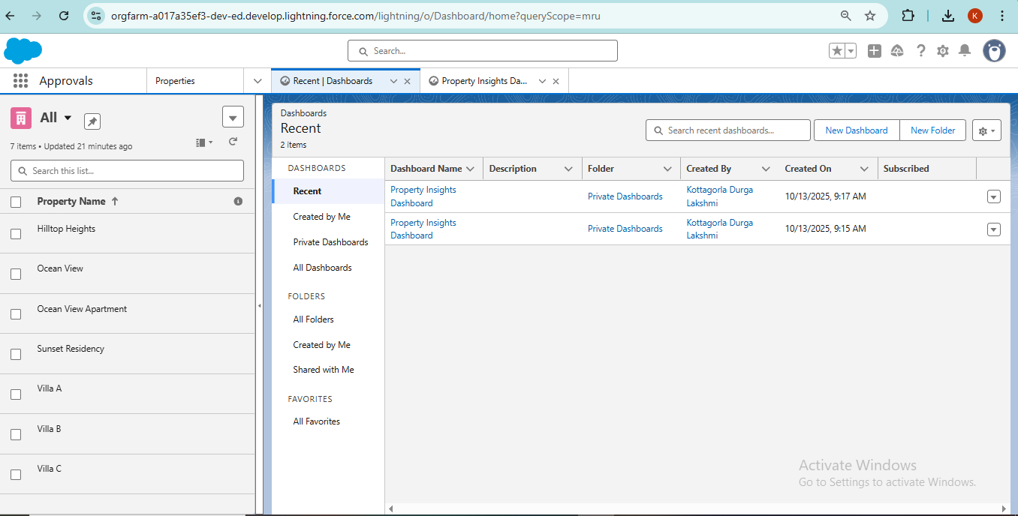

**Fig: Dashboards**

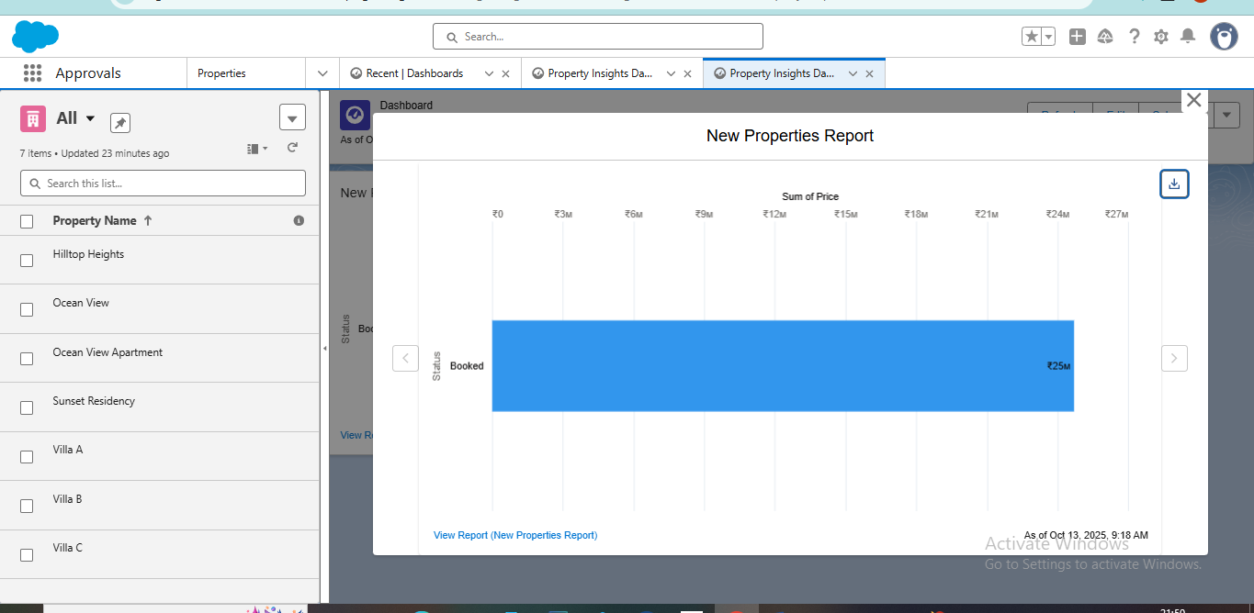

**Fig: Property Dashboard**

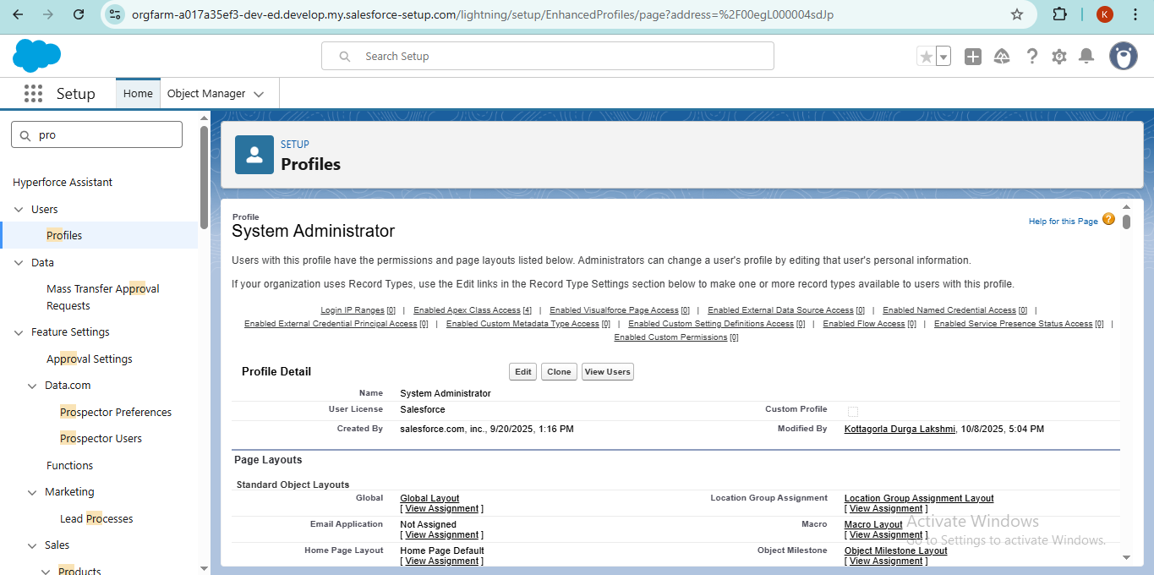

**Fig: Permission Set For Property Object**

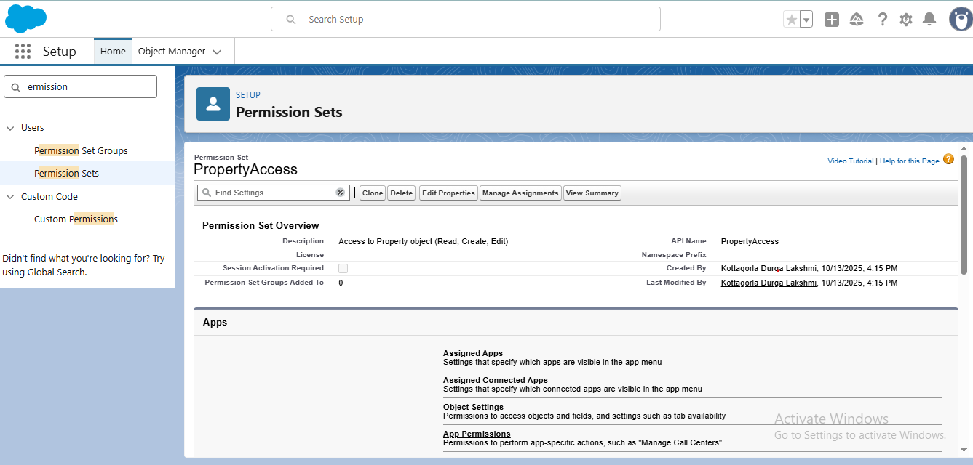

**Fig: Permission Sets**

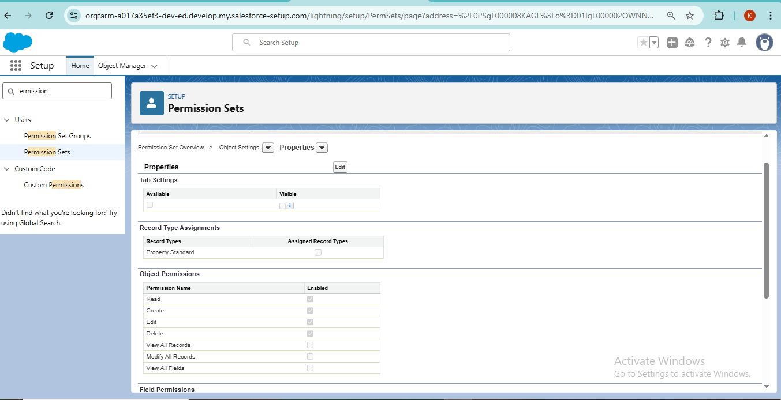

**Fig: Permission Object Settings**

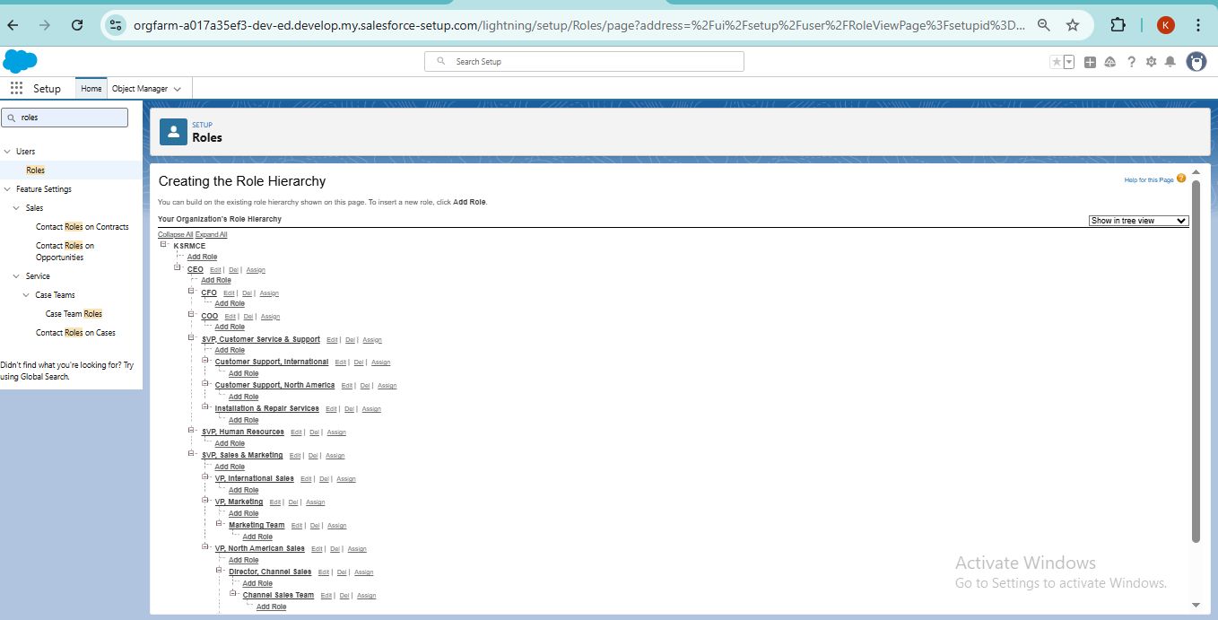

**Fig: Roles Hierarchy**

**Phase 10: Quality Assurance Testing**

* Prepare test cases for all features: objects, approval process, flows, triggers, validation rules
* Each test case includes Input, Expected Output, Actual Output, and a screenshot

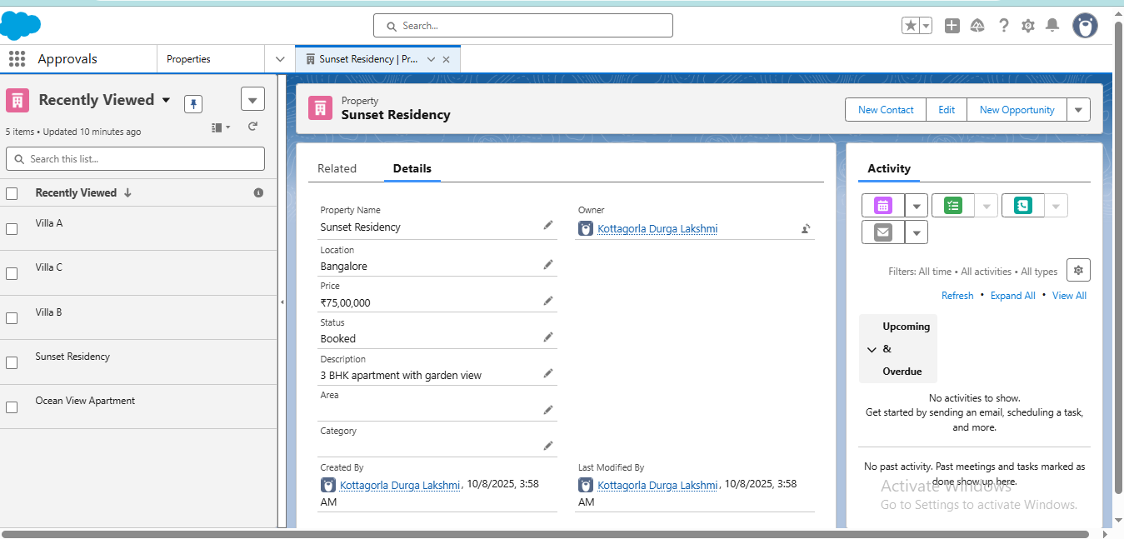

**Fig: Test New Property**

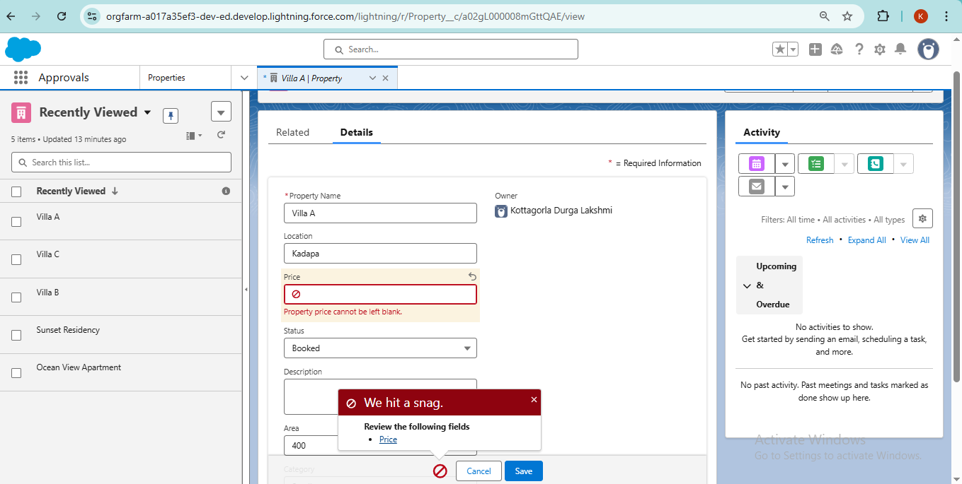

**Fig: Test Validation Rule**

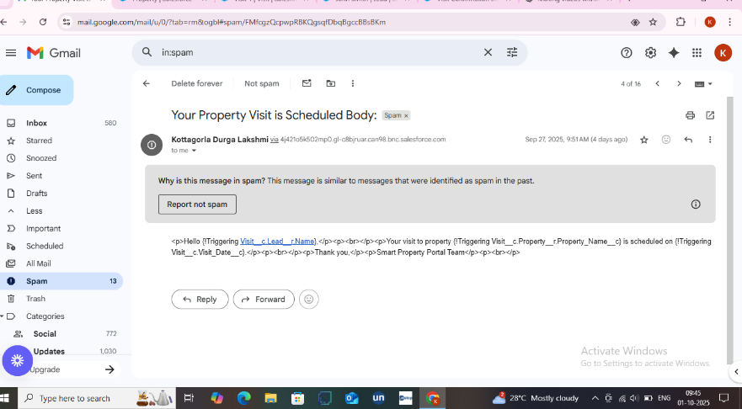

**Fig: Email Received from Visit Confirmation Flow**

**Email Notifications**

* Salesforce sends automated email notifications for visit confirmations or lead updates

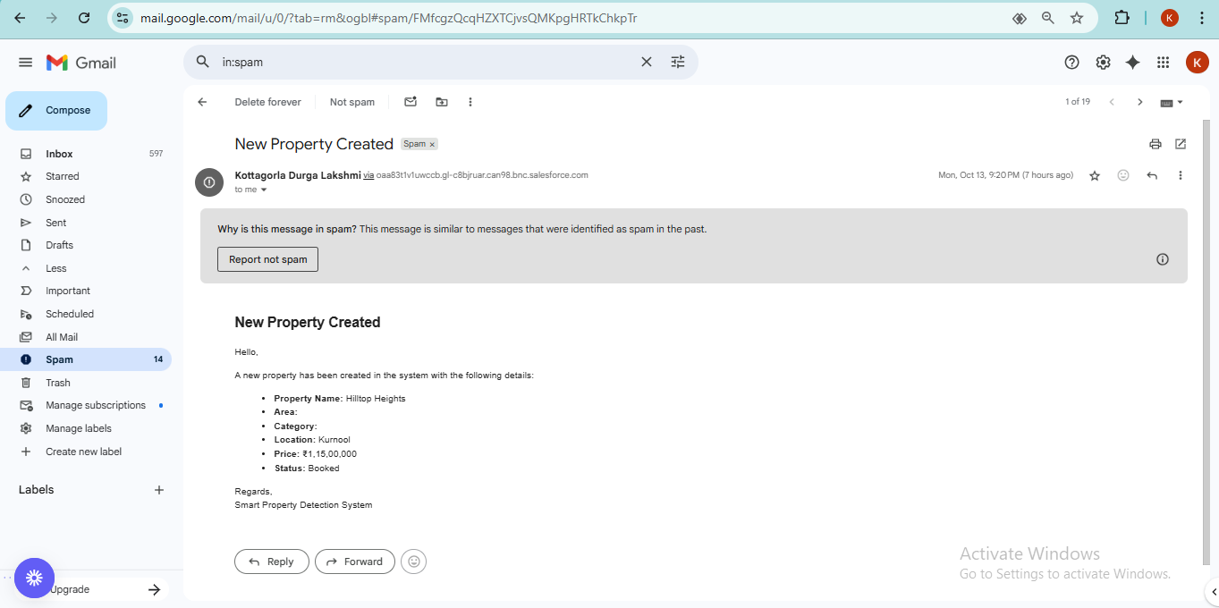

**Fig: Email of New Property Created**

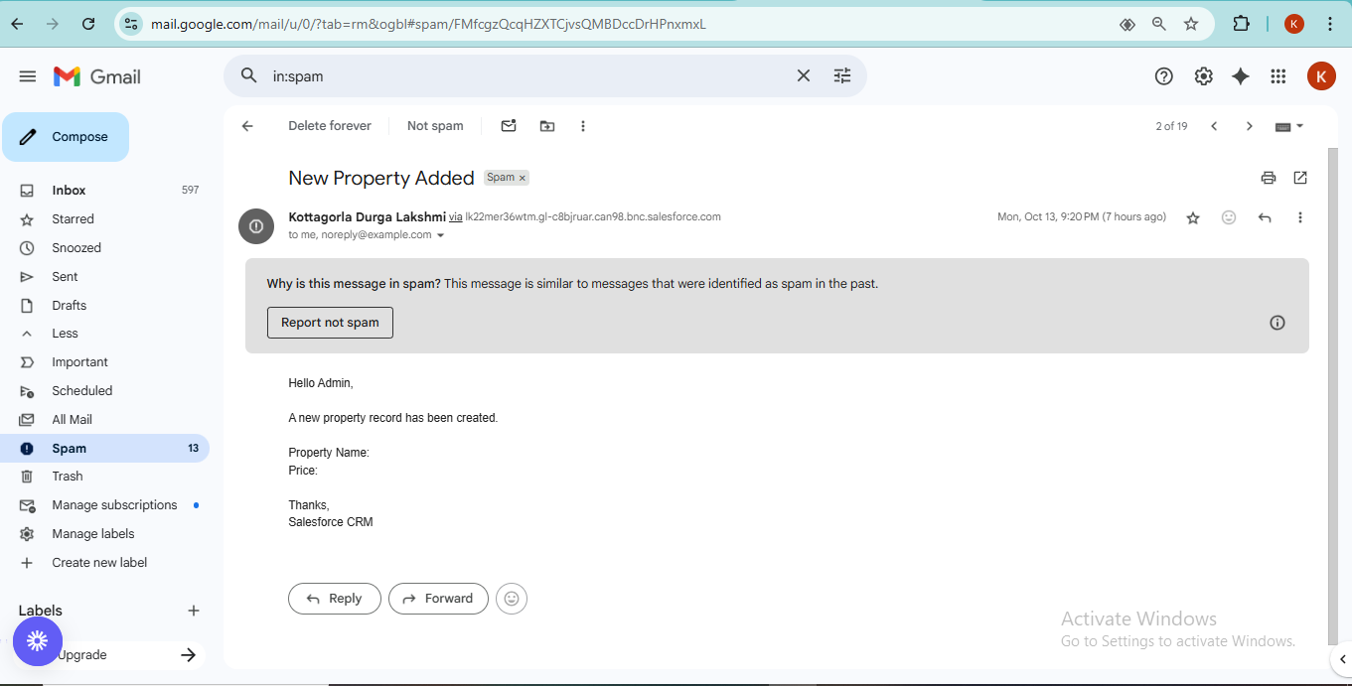

**Fig: Email of New Property Added**

**Conclusion**

The project demonstrates a scalable Salesforce CRM for property, visit, and lead management. Automations, validations, and dashboards enhance operational efficiency, minimise errors, and deliver actionable insights.

**Demo Video Guidelines**

*The project demo video showcases all implemented features, including property, visit, and lead management, flows, validations, Apex triggers, and reports.*

1. Introduction: Yourself and project name; business goal & tools
2. App Overview: Show custom app in App Launcher; key objects
3. UI Demonstration: Create records, show field dependencies, validation rules
4. Business Process Automation: Show flows, workflow rules, process builders, approval processes, triggers
5. Reports & Dashboards: Present analytics dashboards
6. User Management & Security: Show Profiles, Permission Sets, Field-Level Security
7. Error Handling & Debugging: Show debug logs
8. Highlights: Showcase unique features or automations
9. Conclusion: Summarise features, testing, and documentation

**Pro Tips**

* Use your own voice; video 5–15 min; HD resolution
* Quiet environment; logical presentation flow
* Real data examples; highlight LWC, dynamic forms, scheduled flows